Case 10-MEX- Pendant-Were Jaguar-Olmec- Height: 3.25 in.; weight: 1.9 oz.

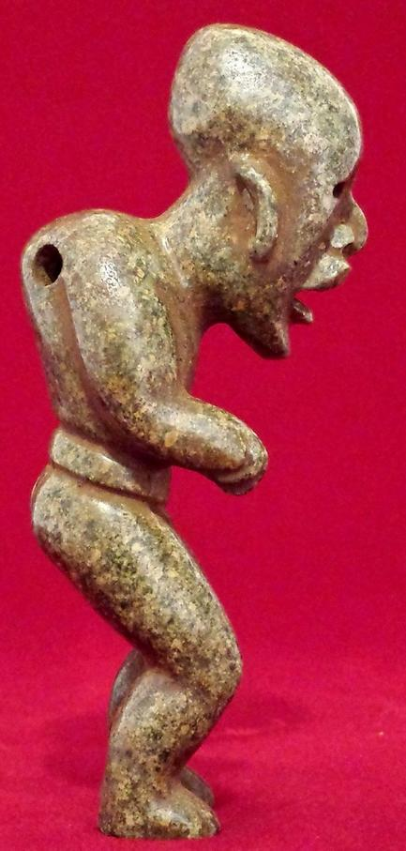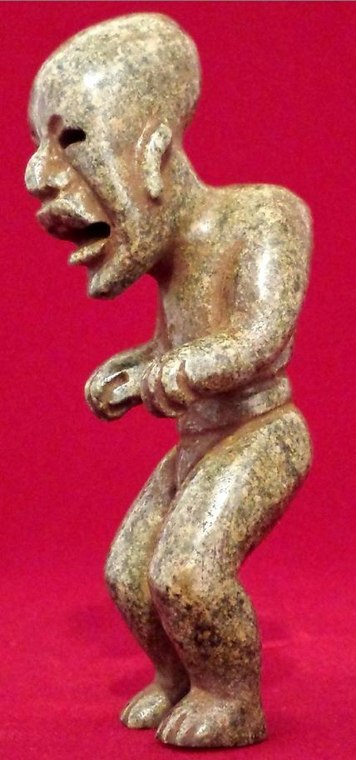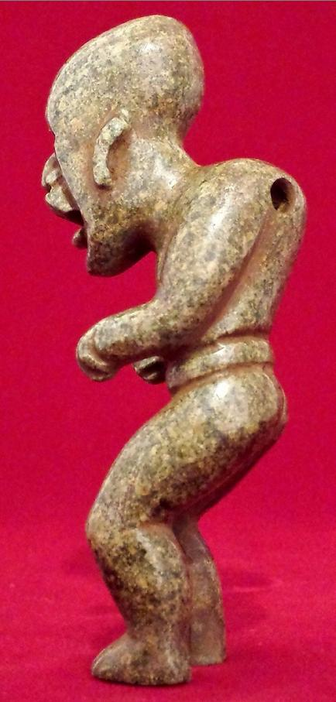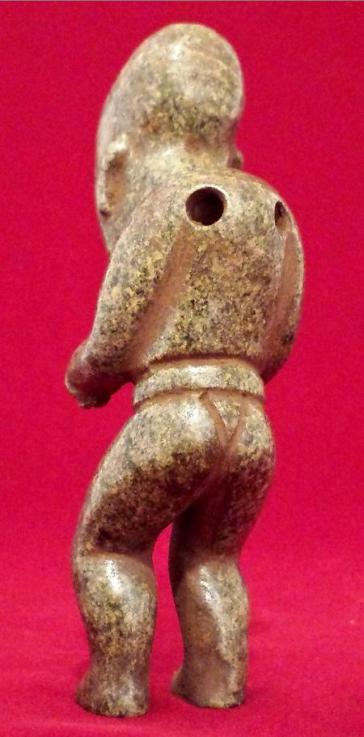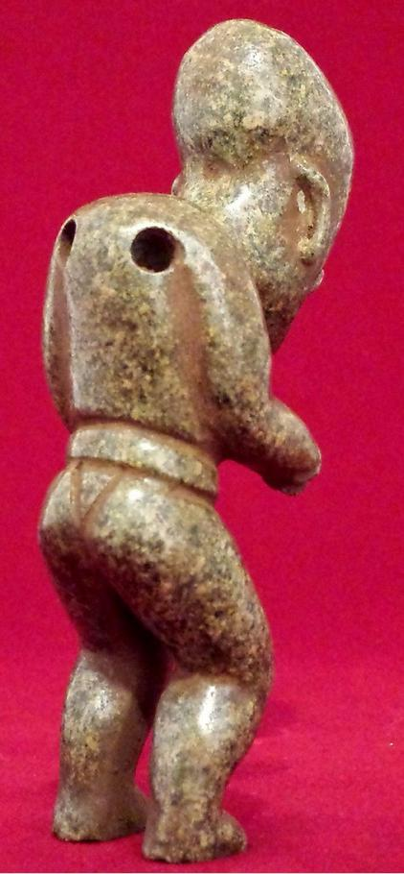

Sold by [amberbead29](http://myworld.ebay.com/amberbead29) ( [50](http://feedback.ebay.com/ws/eBayISAPI.dll?ViewFeedback&userid=amberbead29) )

### Delivery package 1 of 1

Estimated delivery Monday, Jan 25, 2016 - Tuesday, Feb 2, 2016

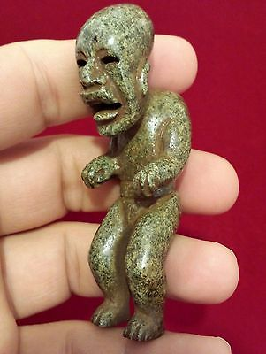

#### [Green Stone Olmec Figurine Pendant Statue Antique Pre Columbian Artifact](http://www.ebay.com/itm/331751648680)

|  |  |
| --- | --- |
| Item price | $248.50 |
| Quantity | 1 |
| Item number | 331751648680 |
| Shipping service | Standard Shipping from outside US |

## Shipping address

Ralph J Coffman Jr

149 Atlantic Ave

Swampscott MA 01907-2427

United States

## Order total

|  |  |
| --- | --- |
| Subtotal | $782.50 |
| Shipping | $32.99 |

**Total**

$815.49

Order placed on

Monday, Jan 18, 2016

Payment method

PayPal

Payment date

Monday, Jan 18, 2016